**1. Write a Python program to reverse the content of the string.**

**Do not use built in**

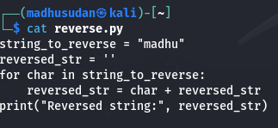

**Output**

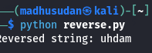

**2. Create a program that performs basic string compression using the counts of repeated characters. For example, the string “aabcccccaaa” would become “a2b1c5a3”.**

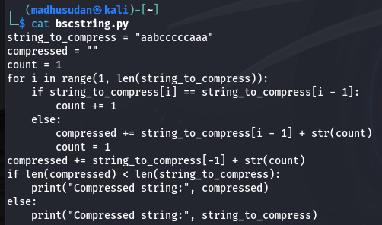

**Output**

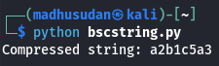

**3. Get the Caesar cipher from the user Decrypt the cipher**

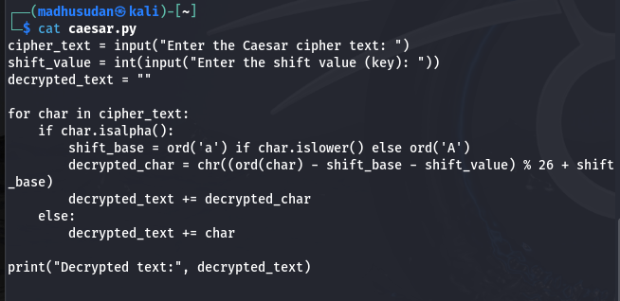

**Output**

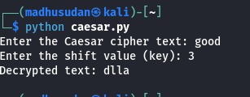

**4. Get the cipher encrypted using shift cipher. Identify the key used to encrypt using brute force**

**ie all the values in the key space**

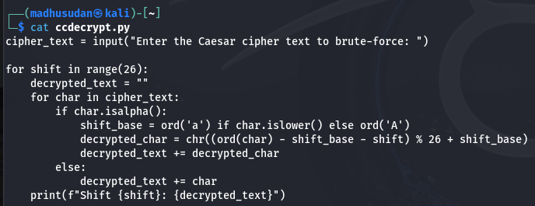

**Output**

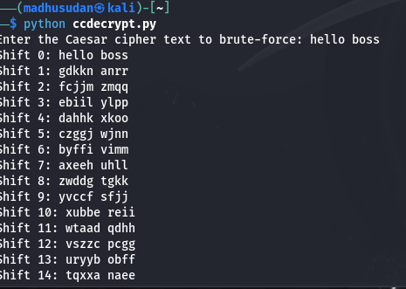

**5. Find the k value , Provided cipher text and plain text**

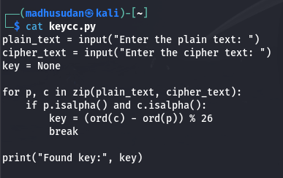

**Output**

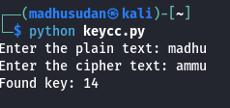

**6. Encrypt and decrypt the string using Atbash cipher**

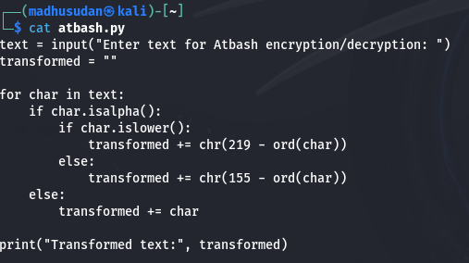

**Output**

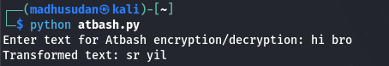

**7. Encrypt and decrypt using Affine cipher**

**add validation**